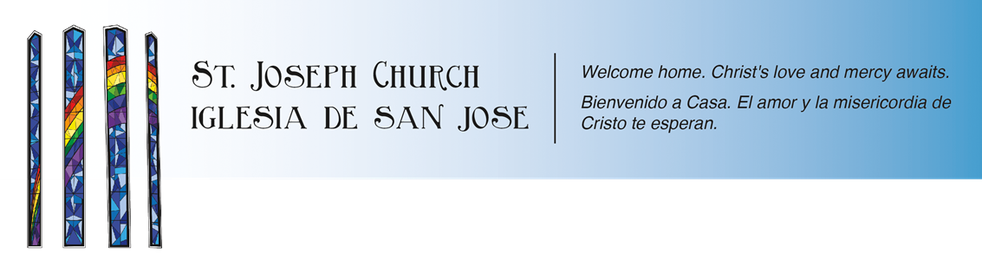

**High School Youth Ministry**

**2020-2021 Schedule**

**Youth Ministry sessions are nights where our trained youth minister and Core team lead the teens to develop a deeper sense of community and faith in a social setting.**

**Usually in a weekly setting, each night the teens are introduced to topics that will range from fun social nights, issue-oriented nights, and teaching nights. Our hope is that every Youth Night is not just fun, but also challenges teens to go deeper in their relationship with God and to know about our Catholic faith.**

**Due to the Covid-19 restrictions and current pandemic, our Youth Ministry requirement and setting will look a little different until we can gather again in person.**

**Standing in place for our Youth Ministry nights will be a weekly virtual bible study or prayer night. The teens will have to attend 3 bible study nights and 2 prayer nights throughout the course of the Confirmation year.**

**Bible Study nights at 7pm via Zoom Prayer nights at 7pm via Zoom**

**10/20/20 10/27/20 11/3/20 10/21/16 10/28/16 11/4/16**

**11/10/20 11/17/20 11/24/20 11/11/16 11/18/16 12/2/16**

**12/1/20 12/8/20 12/15/20 12/9/16 12/16/16 12/6/16**

**\*\*\*12/27/17 – start time 3pm ***12/27/16- Start time 7pm**

**This will be the Youth Ministry schedule until we are allowed to gather again in person. Once we are allowed to gather in person there will be updated youth ministry requirement and calendar. If we still can’t gather by 2021, there will be more bible study nights and prayer nights. Please keep in mind, these nights are separate from the Confirmation nights. For any questions concerning these nights, please contact the front office 805-684-2181 or**

**contact the Youth Minister, Dan Niel**

[**dan@stjosephchurch.org**](mailto:dan@stjosephchurch.org)

