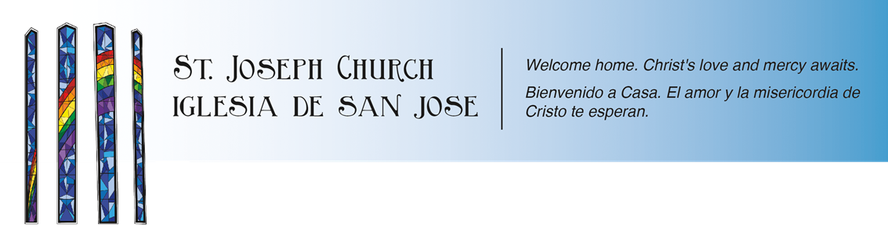
Yr. 2 Confirmation Schedule
2020-2021

Date Event Location Time

10/4/20 (Sun) Yr. 2 Confirmation Mass Church Field 5:30pm-7pm

10/11/20 (Sun) Yr. 2 Confirmation Mass Church Field 5:30pm-7pm

10/18/20 (Sun) Yr. 2 Confirmation Mass Church Field 5:30pm-7pm

10/25/20 (Sun) Yr.2 Confirmation Mass Church Field 5:30pm-7pm

11/1/20 (Sun) Yr. 2 Confirmation Mass Church Field 5:30pm-7pm

11/8/20 (Sun) Yr. 2 Confirmation Mass Church Field 5:30pm-7pm

11/15/20 (Sun) Yr. 2 Confirmation Mass Church Field 5:30pm-7pm

11/22/20 (Sun) Yr. 2 Confirmation Mass Church Field 5:30pm-7pm

12/6/20 (Sun) Yr. 2 Confirmation Mass Church Field 5:30pm-7pm

12/13/20 (Sun) Yr. 2 Confirmation Mass Church Field 5:30pm-7pm

12/20/20 (Sun) Yr. 2 Confirmation Mass Church Field 5:30pm-7pm

Note: By this time in the calendar year we should know what the guidelines are for in person classes. That information might come earlier than 2021. It might come somewhere in November or December. Whenever St. Joseph Church gets the approval for in person classes, all families will get an updated calendar. Yr.2 Confirmation classes will move to every other week, meeting twice a month. Regular mass attendance will still be expected. If nothing changes, then we will use this calendar and format.

1/10/21 (Sun) Yr. 2 Confirmation Mass Church Field 5:30pm-7pm

1/17/21 (Sun) Yr. 2 Confirmation Mass Church Field 5:30pm-7pm

1/24/21 (Sun) Yr. 2 Confirmation Mass Church Field 5:30pm-7pm

1/31/21 (Sun) Yr. 2 Confirmation Mass Church Field 5:30pm-7pm

2/14/21 (Sun) Yr. 2 Confirmation Mass Church Field 5:30pm-7pm

2/21/21 (Sun) Yr. 2 Confirmation Mass Church Field 5:30pm-7pm

2/28/21 (Sun) Yr. 2 Confirmation Mass Church Field 5:30pm-7pm

3/7/21 (Sun) Yr. 2 Confirmation Mass Church Field 5:30pm-7pm

3/14/21 (Sun) Yr. 2 Confirmation Mass Church Field 5:30pm-7pm

3/21/21 (Sun) Yr. 2 Confirmation Mass Church Field 5:30pm-7pm

3/28/21 (Sun) Yr. 2 Confirmation Mass Church Field 5:30pm-7pm

April Classes and Confirmation Mass TBD

Confirmation Classes

Due to COVID-19 restrictions and the pandemic in general, we can’t hold in person classes. We are allowed to have church services outside. As it stands, St. Joseph Church has a drive-in style mass. We have a stage setup for the altar, we have a large field and plenty of parking for cars. We have a sound system for outside and we are also able to connect to FM radio. Confirmation teens and at least 1 parent (the whole family are invited) will attend the 5:30pm Youth Mass outside on the field. Attending mass as a family would be a regular requirement for Confirmation. Instead of inside, mass will take place outside is the only difference. We can catechize and celebrate mass in this unique way.

For a further breakdown, all families need to sign up for a Conversation of Faith. This is a one on one meeting with the family (teen + parents) and the Youth Minister. This meeting will take place via Zoom call. There I can answer any questions you as a family might have.

Keep in mind that during the year, guidelines will change. This schedule is only temporary. Thank you for bearing with us at this time.

